To,
M/S BK EXPORTS,
AHMEDABAD,
Respected Sir,
I am hereby raising the Loading and marking charges for the container loaded from Khammam. My total charges for this container are Rs. 18000/- (Eighteen Thousand Rupees).
Please arrange to make the payment for the same. My Bank details are as under :
Name : SHRIRAM JOSHI
Bank : STATE BANK OF INDIA
A/c No. : 61323570481
Branch : ACB CHHOTI KHOTU
IFSC :SBIN0012899

Please consider this letter as Invoice for my services.
My PAN No. is : CEAPJ1563F
Thank you for your prompt attention. We appreciate your continued partnership.
Yours sincerely,
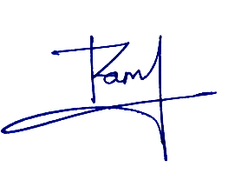
SHRIRAM JOSHI
Mo. No. 7073389533

